Rahim borumandi

903119

home work 1:

write a computer program to interpolate an equation and then plot it, , then compute the

function points { p(3.5)=? , p(7.8)=? }

xi f(xi)

1 1.5709

2 1.5713

3 1.5719

4 1.5727

5 1.5751

6 1.5767

7 1.5785

8 1.5805

9 1.5833

1.Way one……………………………………………………………………………………………………………………………………..

 %%%%%%%%%%%%%%%%%%%%%%%%%%%%%%%%%%%%%%%%%%%%%%%%%%%%%%%%%%%%%%%%%%

% Lagrange Interpolation ; %

% %

% Programmed By:rahim borumandi %

% 1391/3/28 %

% %

%%%%%%%%%%%%%%%%%%%%%%%%%%%%%%%%%%%%%%%%%%%%%%%%%%%%%%%%%%%%%%%%%%

clc;

clear;

disp('Lagrange Interpolation');

disp(' ');

disp('Programmed By:rahim buromandi');

disp(' ');

n=input('Enter the number of data points: ');

disp(' ');

x=zeros(n,1);

y=zeros(n,1);

for i=1:n

x(i)=input(['Enter x' mat2str(i) ': ']);

y(i)=input(['Enter y' mat2str(i) ': ']);

disp(' ');

end

x1=min(x);

x2=max(x);

dx=x2-x1;

x1=x1-0.2\*dx;

x2=x2+0.2\*dx;

xx=x1+(x2-x1)\*(0:0.001:1);

yy=zeros(size(xx));

for k=1:numel(xx)

L=ones(1,n);

for i=1:n

for j=1:n

if j~=i

L(i)=L(i)\*(xx(k)-x(j))/(x(i)-x(j));

end

end

yy(k)=yy(k)+y(i)\*L(i);

end

end

figure;

set(gcf,'color','white');

plot(xx,yy);

hold on;

plot(x,y,'r.','MarkerSize',25);

……………………………………………………………………………………………………………………………………………………………………..

output:

Lagrange Interpolation

Programmed By:rahim buromandi

Enter the number of data points: 9

Enter x1: 1

Enter y1: 1.5709

Enter x2: 2

Enter y2: 1.5713

Enter x3: 3

Enter y3: 1.5719

Enter x4: 4

Enter y4: 1.5727

Enter x5: 5

Enter y5: 1.5751

Enter x6: 6

Enter y6: 1.5767

Enter x7: 7

Enter y7: 1.5785

Enter x8: 8

Enter y8: 1.5805

Enter x9: 9

Enter y9: 1.5833

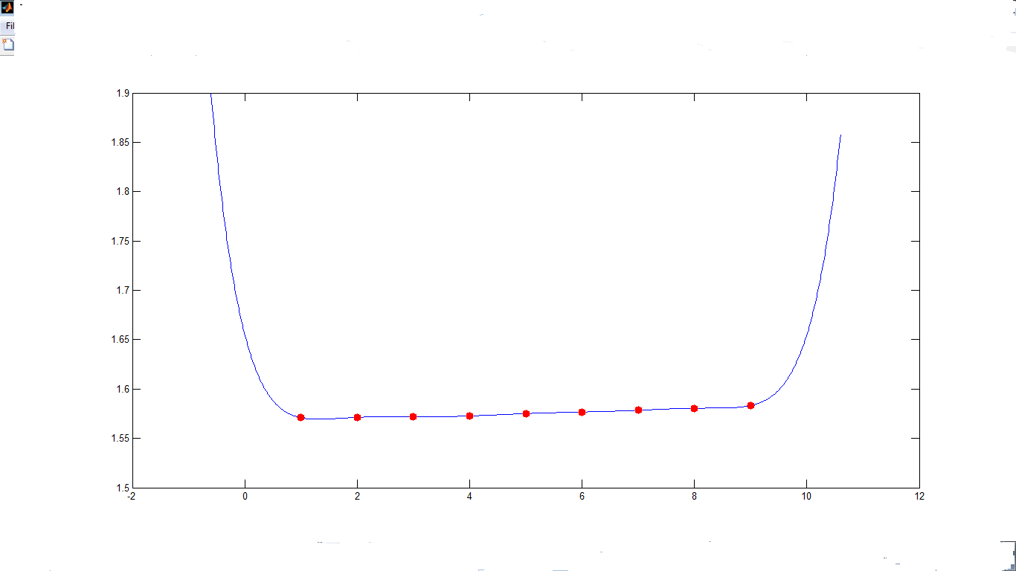

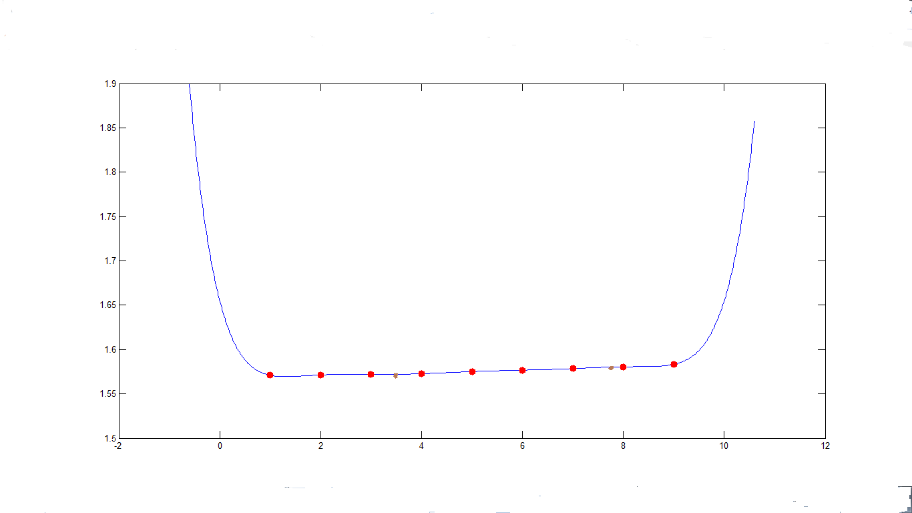

F(3.5) and F(7.8) indicate in polt 2;

F(3.5)=1.572

F(7.8)=1.5803





………………………………………………………………………………………………………………………………………………………………

2.way two

…………………………………………………………………………………………………………………………………………………………..

%%%%%%%%%%%%%%%%%%%%%%%%%%%%%%%%%%%%%%%%%%%%%%%%%%%%%%%%%%%%%%%%%%%%%%%%%%%

%writing a computer program to interpolate an equation and then plot %

%it then compute the function points (m). %

%by rahim borumandi 1391/3/29 %

%%%%%%%%%%%%%%%%%%%%%%%%%%%%%%%%%%%%%%%%%%%%%%%%%%%%%%%%%%%%%%%%%%%%%%%%%%%

clc

A=[1 2 3 4 5 6 7 8 9];

B=[1.5709 1.5713 1.5719 1.5727 1.5751 1.5767 1.5785 1.5805 1.5833];

n=input('enter degree of poly');

p=polyfit(A,B,n);

disp(p);

A2=1:.1:9;

B2=polyval(p,A2);

plot(A,B,'o',A2,B2);

m=input('enter a data to give you value of data');

disp(polyval(p,m));

out put:

enter degree of poly3

-0.0000 0.0003 -0.0006 1.5712



enter a data to give you value of data

enter a data to give you value of data3.5

1.5725

enter a data to give you value of data7.8

1.5804

……………………………………………………………………………………………………………………………………………………………

…………………………………………………………………………………………………………………………………………………….

home work 2:

write a main program with the following subroutin

1) trapezoidal rule

2) simpson's rule

value the integral ∫ (1-x^2)^(3/2) dx,0,1

and compare with exact number

exact = ∫ (1-x^2)^(3/2) dx,0,1= 0.589048622

1)…………………………………………………………………………………………………………………………………………

%%%%%%%%%%%%%%%%%%%%%%%%%%%%%%%%%%%%%%%%%%%%%%%%%%%%%%%%%%%%%%%%%%%%%%%%%

%this program is wrriten to compute value the integral (1-x^2)^(3/2) %

%dx,0,1 by rahim borumandi 1391/3/27 in trapezoidal rule %

%%%%%%%%%%%%%%%%%%%%%%%%%%%%%%%%%%%%%%%%%%%%%%%%%%%%%%%%%%%%%%%%%%%%%%%%%

clc

n = input('Please tell me “n” value:');

if ( n>0)

h=1/n;

sum=h/2;

i=1;

while i<n;

x=i\*h;

y = sqrt((1-x^2)^3);

sum=sum+(h)\*y;

i=i+1;

end

disp('sum=');

fprintf('%d ', sum);

exact=.589048622;

if( sum > exact )

disp('sum>exact');

end

if (sum <exact)

disp('sum <exact');

end

if (sum==exact)

disp('sum=exact');

end

disp('type "end" please to close program')

end

output: Please tell me “n” value:40

sum=

5.890415e-001 sum <exact

type "end" please to close program

>>

……………………………………………………………..

Please tell me “n” value:466

sum=

5.890486e-001 sum <exact

type "end" please to close program

>>

………………………………………………………………………………………………………………………………………………………………..

2)

%%%%%%%%%%%%%%%%%%%%%%%%%%%%%%%%%%%%%%%%%%%%%%%%%%%%%%%%%%%%%%%%%%

%simpson way compute value the integral (1-x^2)^(3/2) dx,0,1 ; %

%by rahim borumandi 1391/3/29 %

%%%%%%%%%%%%%%%%%%%%%%%%%%%%%%%%%%%%%%%%%%%%%%%%%%%%%%%%%%%%%%%%%%

clc

n = input('Please tell me even “n” value:');

if ( mod(n,2)==0)

h=1/n;

sum=0;kum=0;sham=h/3;

i=1;

while i<n;

i=i+2;

x=i\*h;

y = sqrt((1-x^2)^3);

sum=sum+(h/3)\*4\*y;

end

i=2;

while i<n;

x=i\*h;

i=i+2;

y = sqrt((1-x^2)^3);

kum=kum+(h/3)\*2\*y;

end

sham=sham+sum+kum;

disp('sham=');

fprintf('%d ', sham);

exact=.589048622;

if( sham > exact )

disp('sham>exact');

end

if (sham<exact)

disp('sham <exact');

end

if (sham==exact)

disp('sham=exact');

end

disp('type "end" please to close program')

end

if( mod(n,2)~=0)

disp ('n is no even ');

end

output:

Please tell me even “n” value:260

sham=

5.839206e-001 sham <exact

type "end" please to close program

……………………………………………………………..

Please tell me even “n” value:25606

sham=

5.889966e-001 sham <exact

type "end" please to close program

……………………………………………………………………

By knowing correct value for x x (-1,1)

fplot('sqrt((1-x\*x)^3)',[-1 1])



End ;1391/3/29